**BT307 Lab 5**

1. **Name:** Aditya Jindal **Roll No.:** 210106004
2. 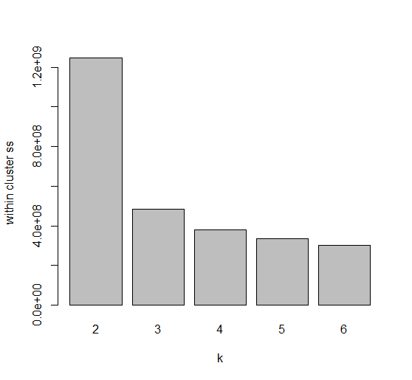
3. We chose k=3 for final clustering because it has lesser number of overlapping and better segregation.

